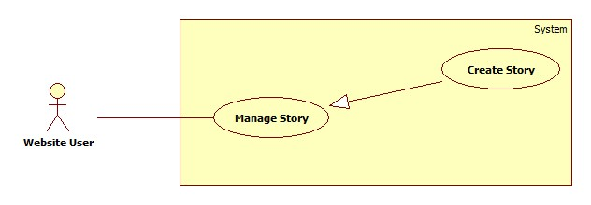

Figure 1: <Website User> Create Story Use Case

|  |  |  |  |
| --- | --- | --- | --- |
| **USE CASE – WU???** | | | |
| **Use Case No.** | WU??? | **Use Case Version** | 2.0 |
| **Use Case Name** | Create Story | | |
| **Author** | Tran Le Tuan | | |
| **Date** | 30/09/2014 | **Priority** | Normal |
| **Actor:** Website User  **Summary:**  This use case allow website user to create story.  **Goal:**  Create a story success.  **Triggers:**   * User can create new story * On Home page, click on link “Create Story” in menu bar.   **Preconditions:**   * User must logged in the system with the role is website user.   **Post Conditions:**   * **Success:** The story will be added from server and database * **Fail:** No story added   **Main Success Scenario:**   |  |  |  | | --- | --- | --- | | Step | Actor Action | System Response | | 1 | Click menu item“Create Story” | Redirect to Create Story page, contains :   * Name: label * Description : label * Share with: combobox * Button “Add Albums” * Button “Done” | | 2 | Fill information and click on “Add Albums” button | Show a dialog to choose albums to add. | | 3 | Click “Share with: “ combobox | Show a combobox to choose type share. | | 4 | Click “Add” button.  [Alternative 1] | Redirect to Create Story page. | | 5 | Click “Done” button. | An message is display: “Are you sure to create this story ?”. | | 6 | Click “Ok” button | The story will add into server and database.  An message is display: “Your story created success.”. |   **Alternative Scenario:**   |  |  |  | | --- | --- | --- | | No | Actor Action | System Response | | 1 | [Alternative 1]  Click “Cancel” button. | Albums will not choose. Redirect to Create Story page. | | 3 | [Alternative 2]  Click “Cancel” | The story will not create. Redirect to Create Story page. |   **Exceptions:** N/A  **Relationships:** Manage Story.  **Business Rules:** N/A | | | |

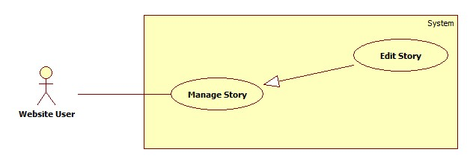

Figure 1: <Website User> Edit Story Use Case

|  |  |  |  |
| --- | --- | --- | --- |
| **USE CASE – WU???** | | | |
| **Use Case No.** | WU??? | **Use Case Version** | 2.0 |
| **Use Case Name** | Edit Story | | |
| **Author** | Tran Le Tuan | | |
| **Date** | 30/09/2014 | **Priority** | Normal |
| **Actor:** Website User  **Summary:**  This use case allow website user to create story.  **Goal:**  Edit a story success.  **Triggers:**   * User can edit a story * User must do these step to edit a story: * On Home page, click on “Manage Photos” in menu bar.   **Preconditions:**   * User must logged in the system with the role is website user.   **Post Conditions:**   * **Success:** The story will be edit and save from server and database. * **Fail:** No story edited.   **Main Success Scenario:**   |  |  |  | | --- | --- | --- | | Step | Actor Action | System Response | | 1 | Click menu item“Manage Photos” | Redirect to story timeline page. | | 2 | Choose story to edit. | Rediect to edit story page. | | 3 | Fill information into table: | Table contain:   * Name: label * Description : label * Share with: combobox * Button “Add Albums” * Button “Done” | | 4 | Fill information and click on “Add Albums” button | Show a dialog to choose albums to add. | | 5 | Click “Add” button.  [Alternative 1] | Redirect to Edit Story page. | | 6 | Click “Done” button. | An message is display: “Are you sure to change this story ?”. | | 7 | Click “Ok” button | The story will add into server and database.  An message is display: “Your story edited success.”. |   **Alternative Scenario:**   |  |  |  | | --- | --- | --- | | No | Actor Action | System Response | | 1 | [Alternative 1]  Click “Cancel” button. | Albums will not choose. Redirect to Edit Story page. | | 3 | [Alternative 2]  Click “Cancel” | The story will not create. Redirect to Edit Story page. |   **Exceptions:** N/A  **Relationships:** Manage Story.  **Business Rules:** N/A | | | |

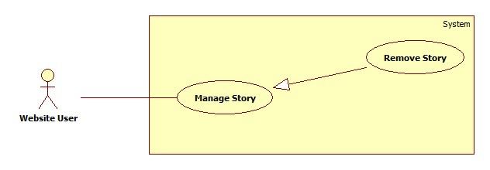

Figure 1: <Website User> Remove Use Case

|  |  |  |  |
| --- | --- | --- | --- |
| **USE CASE – WU???** | | | |
| **Use Case No.** | WU??? | **Use Case Version** | 2.0 |
| **Use Case Name** | Remove Story | | |
| **Author** | Tran Le Tuan | | |
| **Date** | 30/09/2014 | **Priority** | Normal |
| **Actor:** Website User  **Summary:**  This use case allow website user to remove story.  **Goal:**  Remove a story success.  **Triggers:**   * User can remove story. * User must do these step to remove story: * On Home page, click on “Manage Photos” in menu bar.   **Preconditions:**   * User must logged in the system with the role is website user.   **Post Conditions:**   * **Success:** The story will be removed. * **Fail:** No story added   **Main Success Scenario:**   |  |  |  | | --- | --- | --- | | Step | Actor Action | System Response | | 1 | Click menu item“Manage Photos” | Redirect to Manage Photos page. | | 2 | Choose story to delete. Click “Delete”.  [Alternative 1] | An message is display: “Are you sure to delete this story ?”. | | 3 | Click “Ok” button.  [Alternative 1] | The story will add into server and database.  An message is display: “Your story deleted success.”. | |  |  |  | |  |  |  |   **Alternative Scenario:**   |  |  |  | | --- | --- | --- | | No | Actor Action | System Response | | 1 | [Alternative 1]  Click “Cancel” button. | Story will not detele. Redirect to Manage Photos page. | |  |  |  |   **Exceptions:** N/A  **Relationships:** Manage Story.  **Business Rules:** N/A | | | |